Update method for IP-301
- Go to http://192.168.1.8:9999/update.htm . (192.168.1.8 is your VoIP phone IP address)
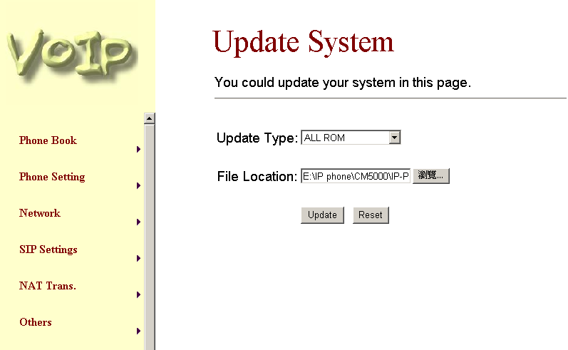
- Load the “rom” file in the ‘File Location’ and press ‘Update’ icon.
- Please make sure there is no problem for the power supply during updating, otherwise, the unit will die.

